**JIRA-TOOL-IMPLEMENTATION-DOCUMENT**

**Name:**Podili Saikumar

**Role:**Jr.Software Developer

**Project :**Wine Mart

**Employee Id:** ACFS2382

**JIRA:**JIRA is a software testing tool developed by the Australian Company Atlassian. It is a bug tracking tool that reports all the issues related to your software or mobile apps. The word JIRA comes from the Japanese word, i.e., "Gojira" which means Godzilla.JIRA is based on the Agile methodology and the current version of the Jira is 6.

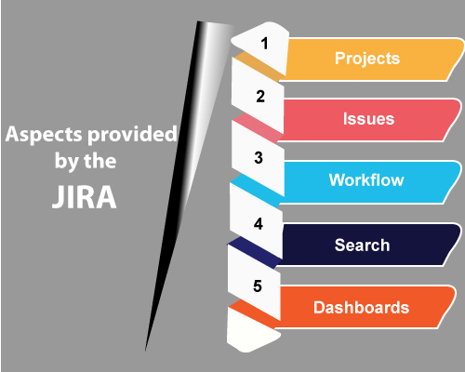

**• Projects:** It is used to manage the defects very effectively.

• **Issue:** It is used to track and manage the defects/issues.

• **Workflow:** Processes the Issue/Defect life cycle. Suppose we have a business requirement, we create the technical design and from the technical design, we create the test cases. After creating the test cases, coding is done, and then testing is performed on the project. This design workflow is possible by using Jira.

• **Search:** Find with ease. Suppose we have done with a project at the beginning of the December and its version is 1.0. Now, we move to version 1.1 and completed at the end of December. What we are doing is that we are adding new versions. Through Jira, we can get to know that what happened in the earlier versions, how many defects occurred in the earlier projects and the learning we achieve from the earlier projects.

**• Dashboards:** Dashboard is a display which you see when you log in to the Jira. You can create multiple dashboards for multiple projects. You can create the personal dashboard and can add the gadgets in a dashboard so that you can keep track of the assignments and issues that you are working on.

**Scrum:** We have studied the Agile methodology where Agile is a set of beliefs which should be followed to develop the software development project. On these beliefs or values, there is many models have developed, and in which one of the models is a scrum.

**Before going to deep in Scrum, you should know the meanings of some basic terms:**

O **Scrum:** Scrum is an agile framework that helps you to organize, iterate, and continue the same project that you are working on. In scrum, a product is built in the series of iterations known as sprints or parts.

O **Sprint:** Sprint is a time-boxed period in which the scrum team needs to finish the set amount of work. Each sprint has a specified timeline, i.e., 2 weeks to 1 month. The scrum team agrees with this timeline during the sprint planning meeting.

O **Scrum Master:** Scrum Master is defined as a facilitator or servant-leader to the Scrum development team. Scrum Master must ensure that scrum principles are followed.

O **Scrum development team:** A scrum development team is a collection of individual members that includes developers, QA, and scrum master. It decides and provides the effort estimate. The recommended size of the scrum team is between 5 and 9 members.

**How does Scrum work**

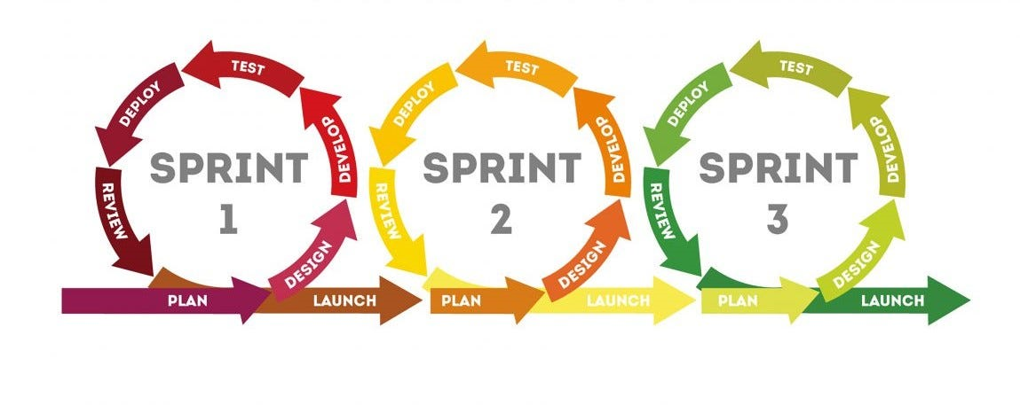

In the Waterfall model, we have read that the first whole requirements are done, then the whole designing is done, then whole development is done, and then whole testing and deployment is done. This model takes full lifecycle of the product, and then the only product is viewable to the client.

While Scrum says that consider a small part of the software and then plan it, build it, test and finally review it. This small module which has been developed will be shown to the customers. For example, we need to develop the e-commerce website, which can be broken into a number of sprints or modules such as login page, payment page, cart page, etc. Then, each module is developed individually and shown to the customers simultaneously. Therefore, we can say that after the completion of each sprint, the product is shipped to the client, though not the complete product but the part of the functionality.

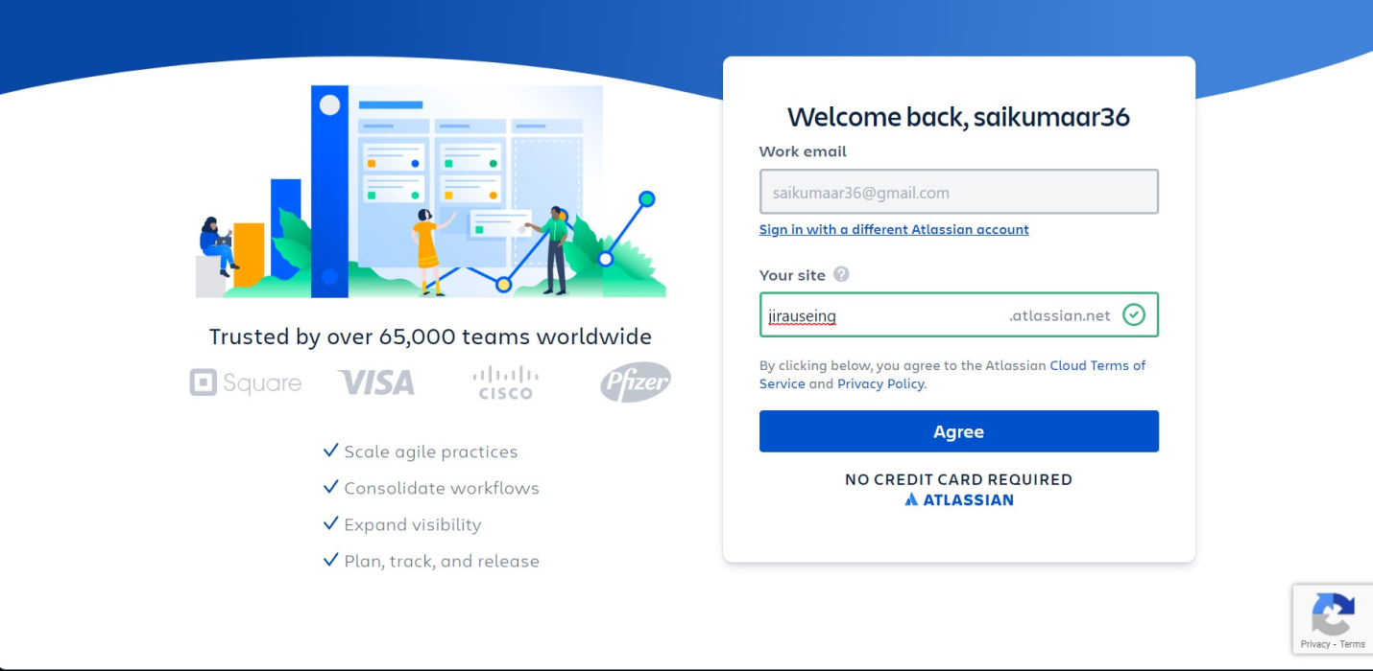

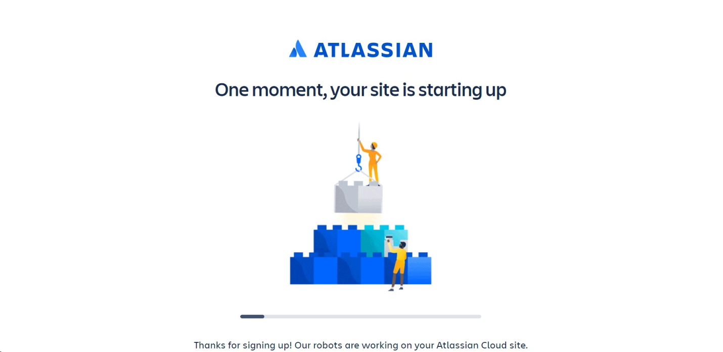

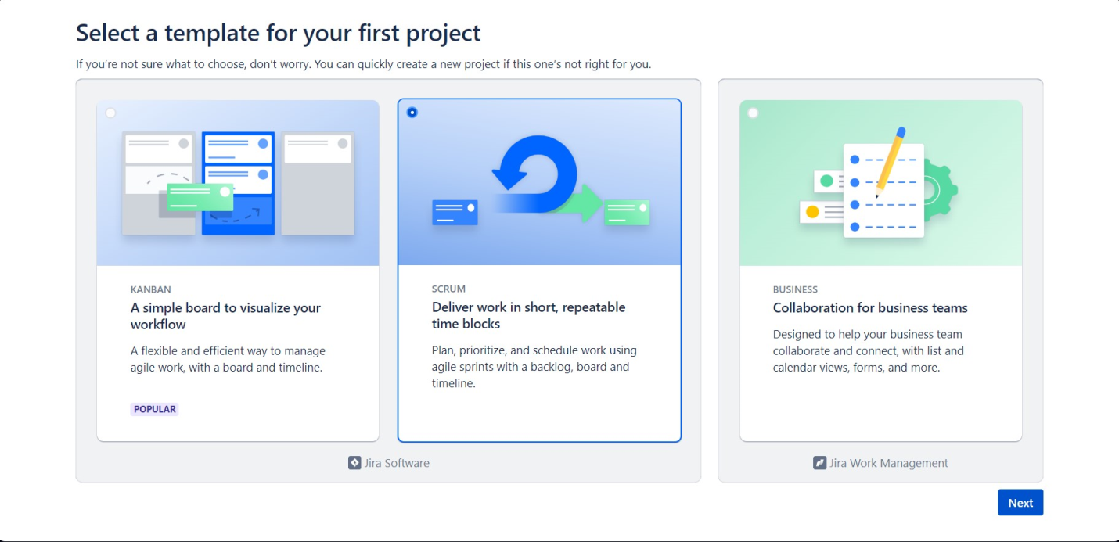

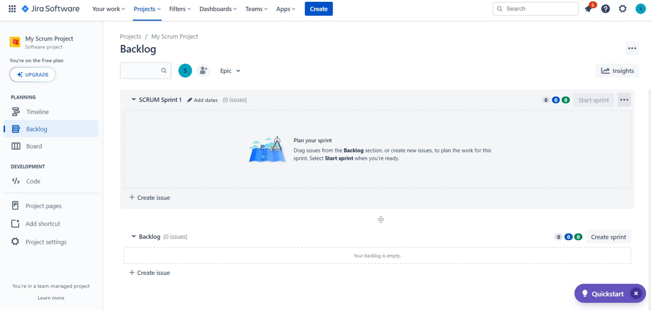

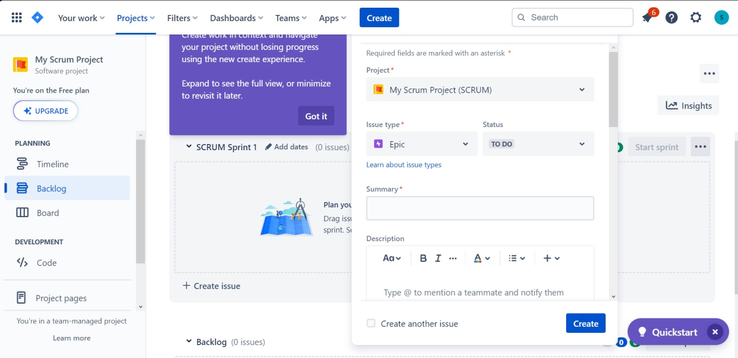

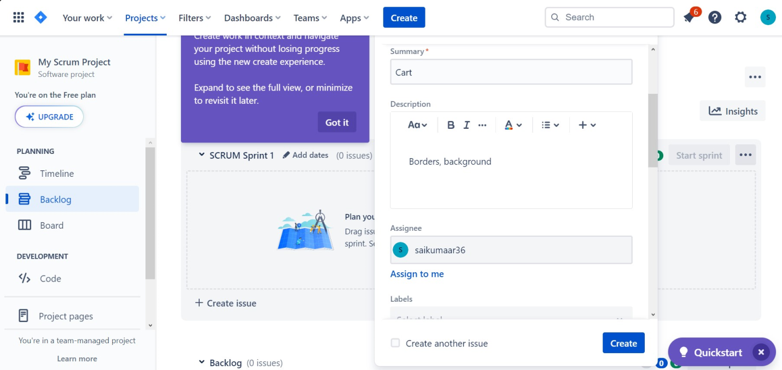

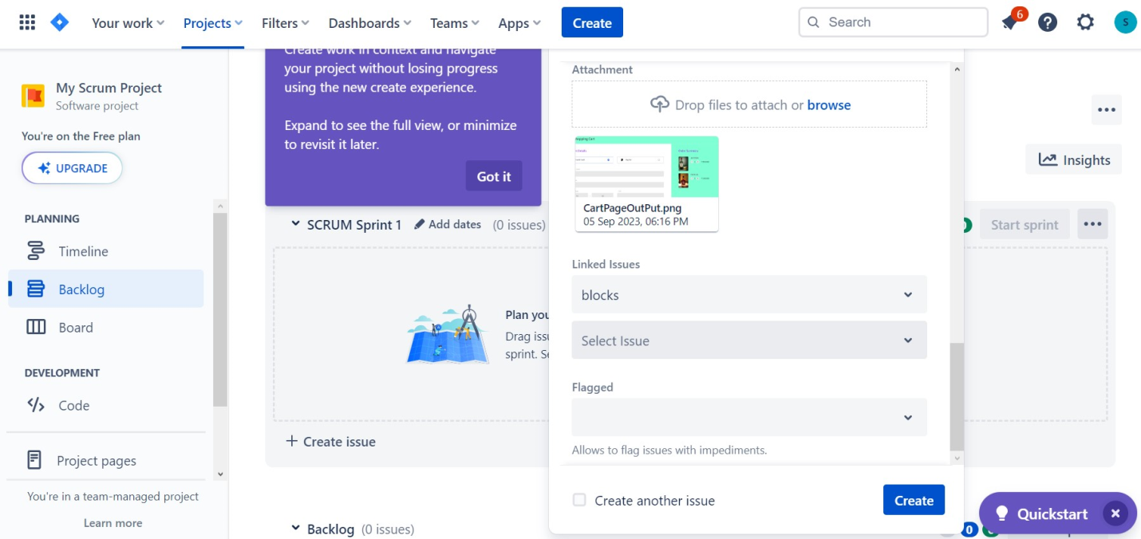

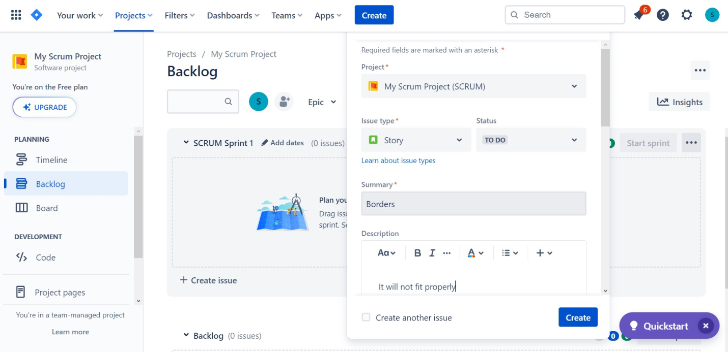

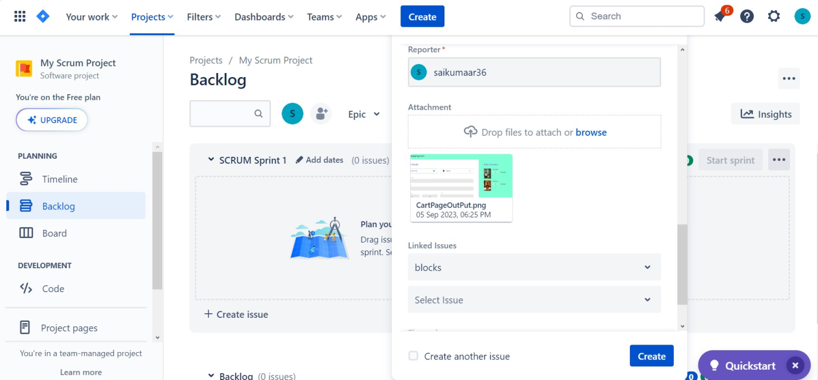

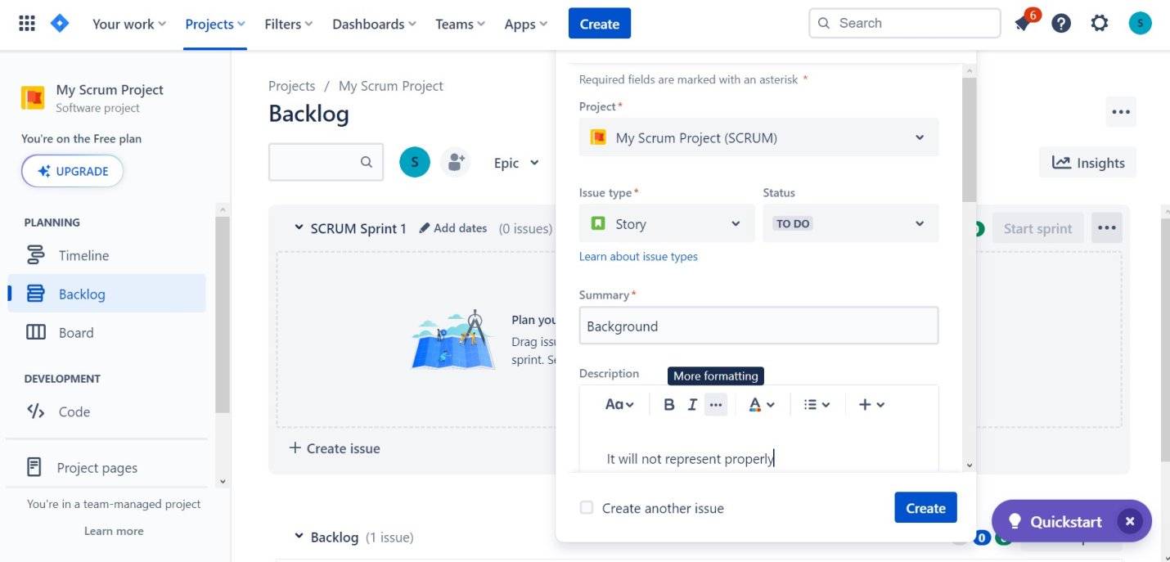

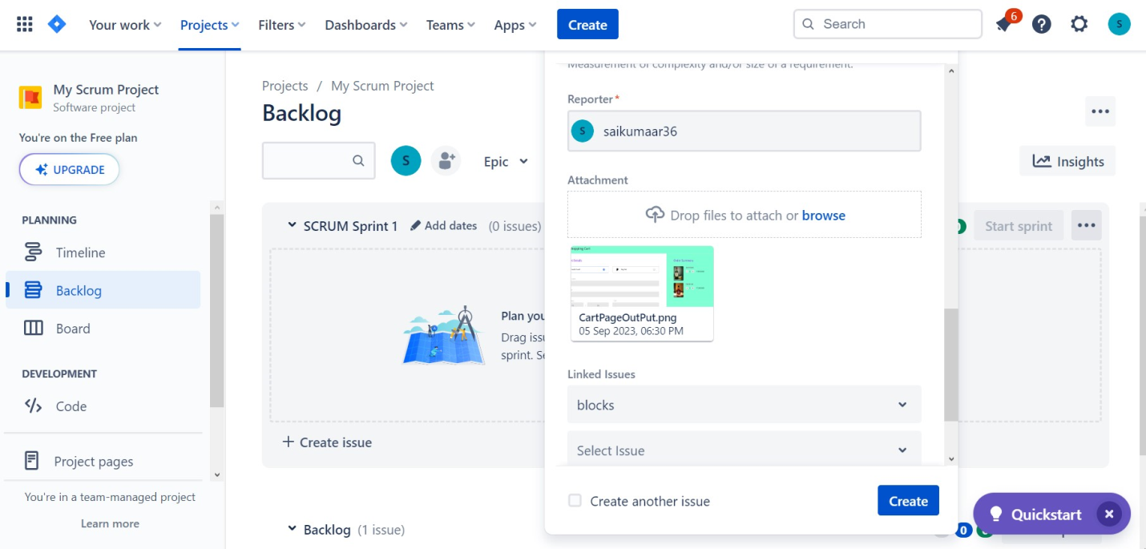

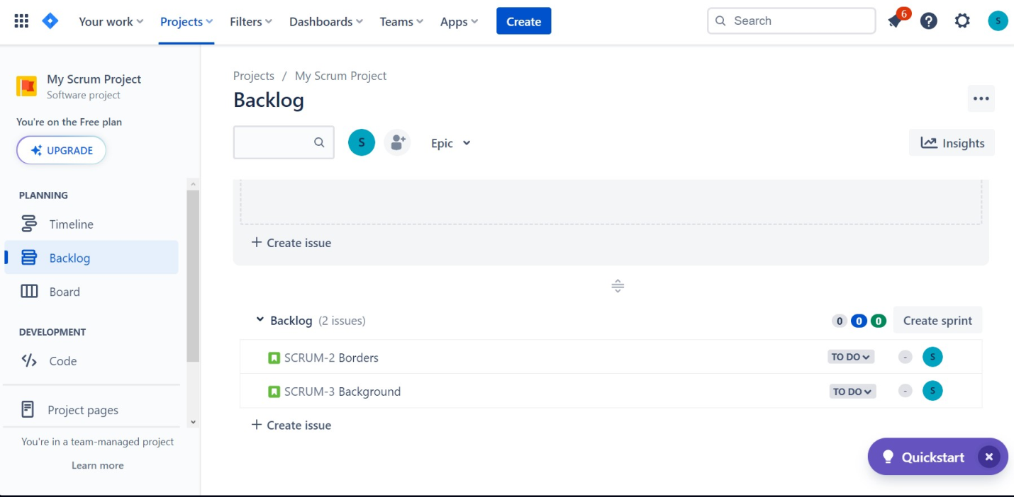

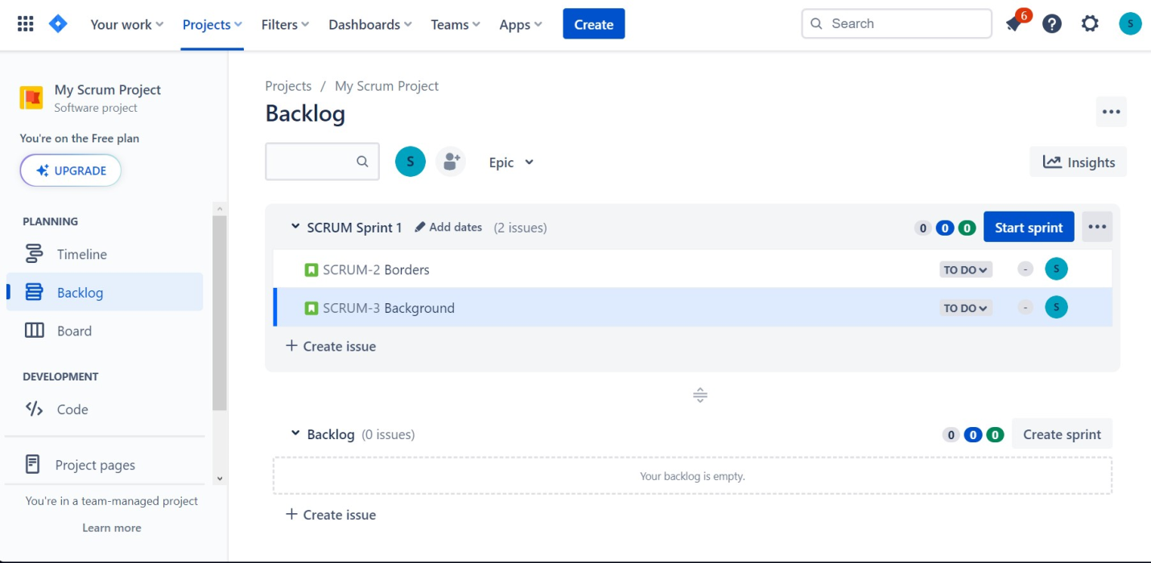

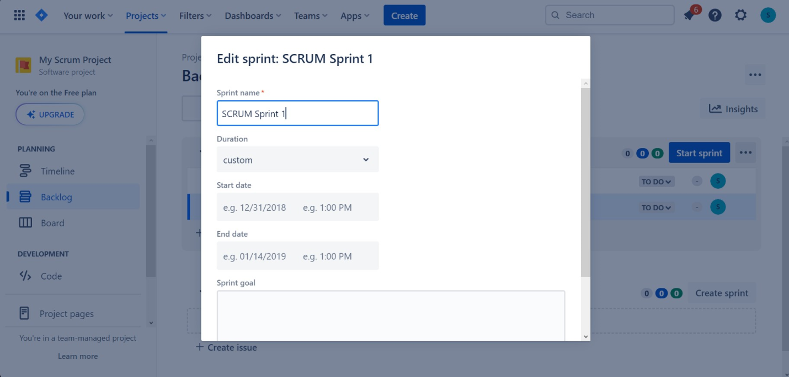

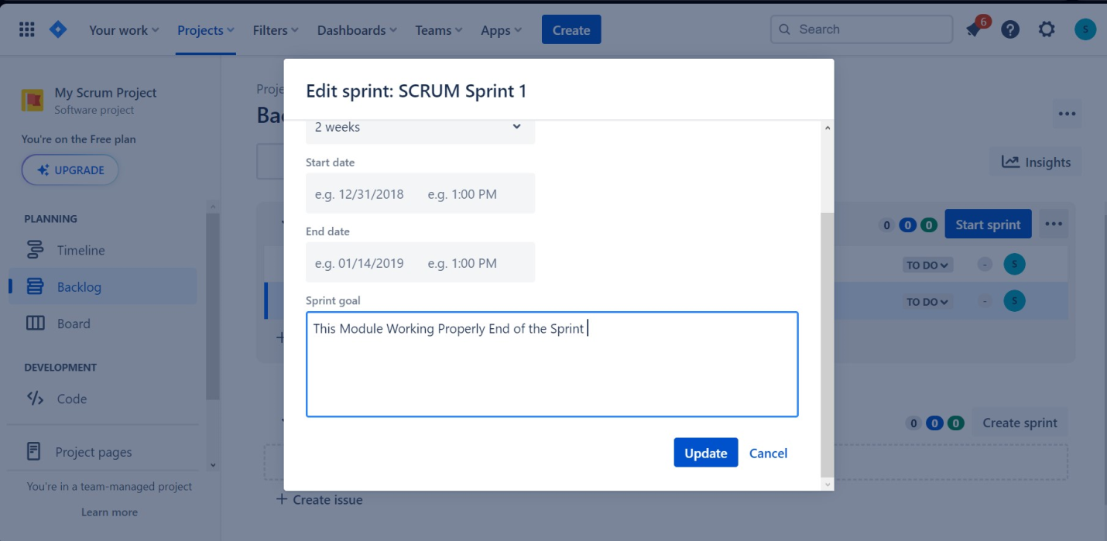

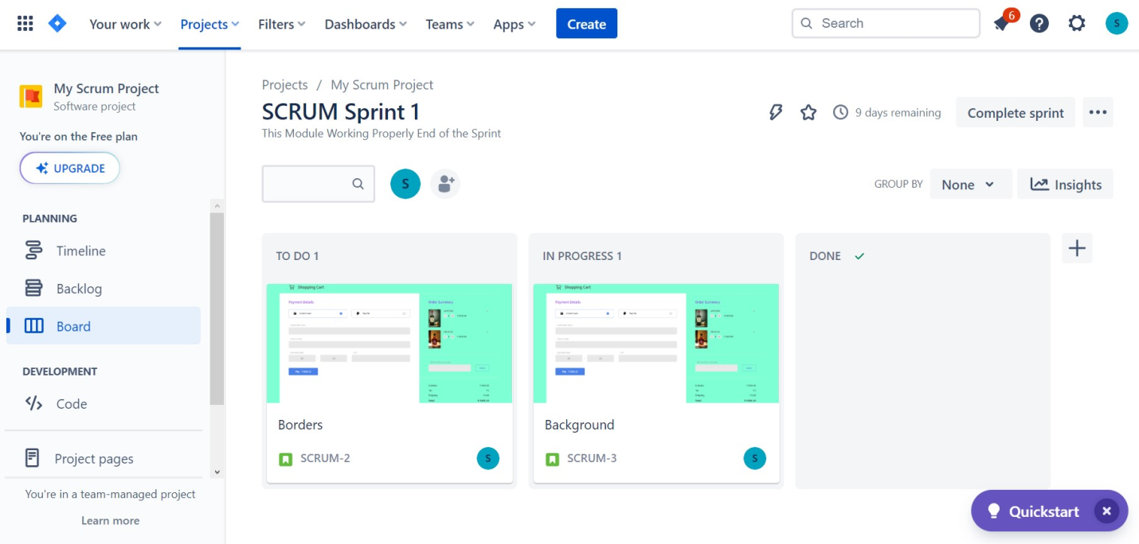

**Thank You**